**ECEN 325 - Lab Report**

**Lab Number: 1**

**Lab Title: First Order Circuits**

**Section Number: 503**

**Student’s Name:** [Alex Allahar](mailto:alex.allahar@tamu.edu)

**Student’s UIN: 928009686**

**Date: 09/02/23**

**TA: Ángel Ocasio-Rodriguez**

**Simulations:**

**Low Pass Filter**

1. Low Pass Filter Bode Plot

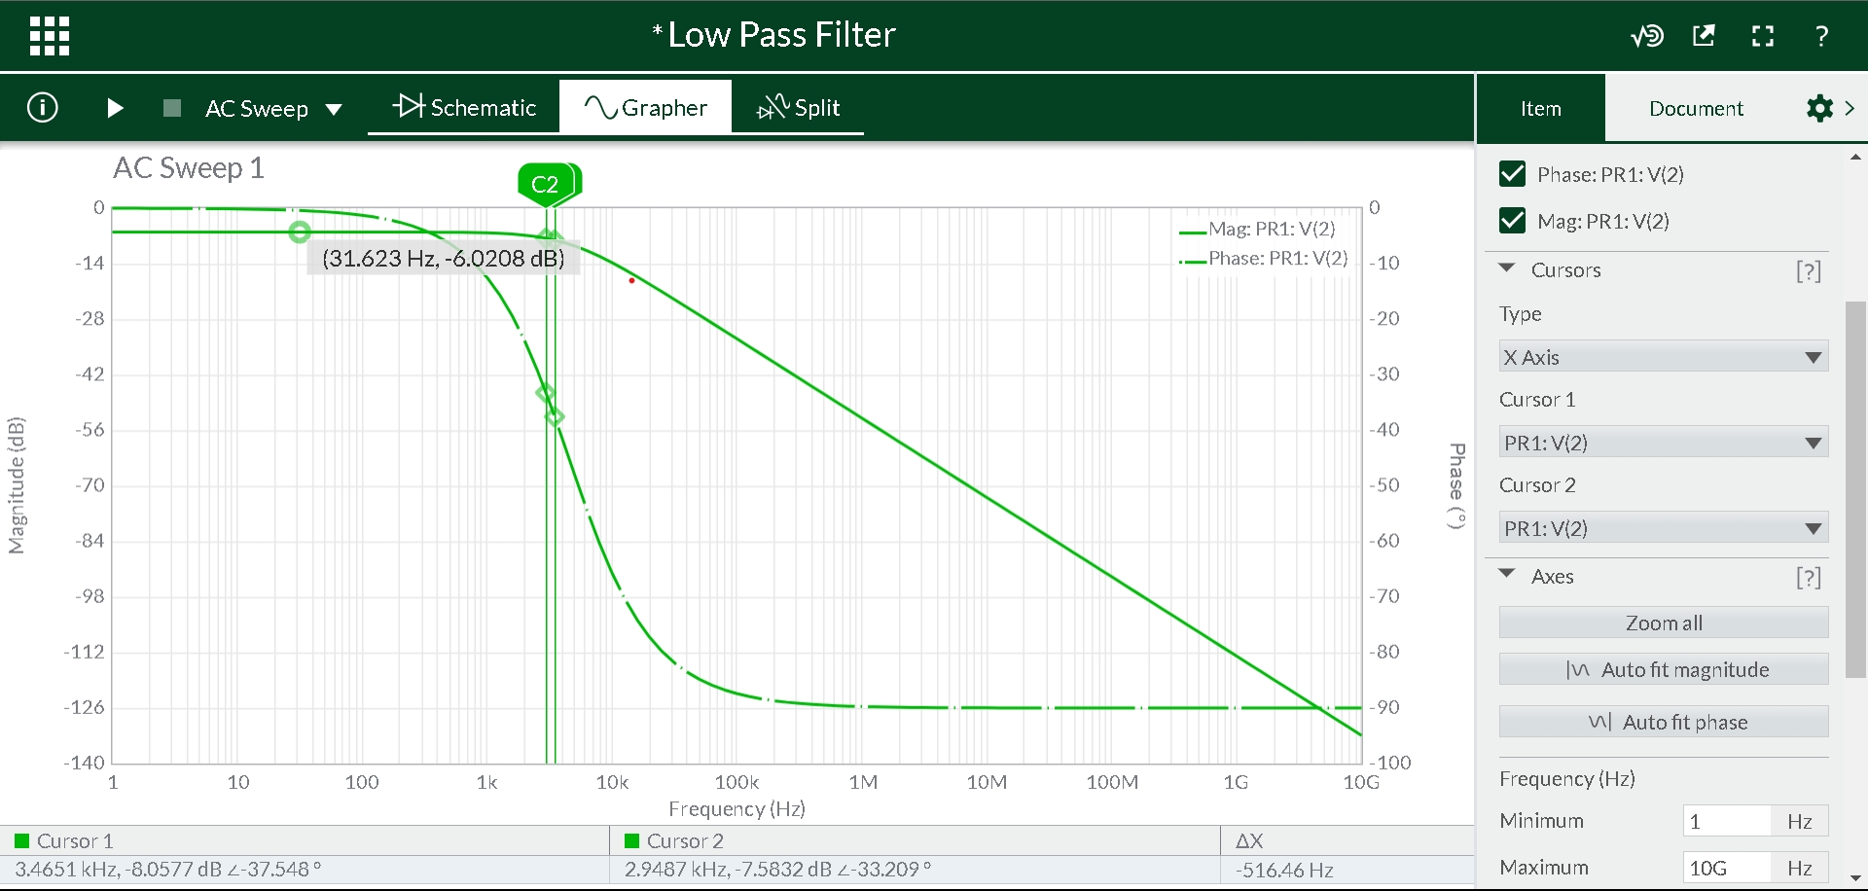

1. Low Pass 4kHz Transient Plot

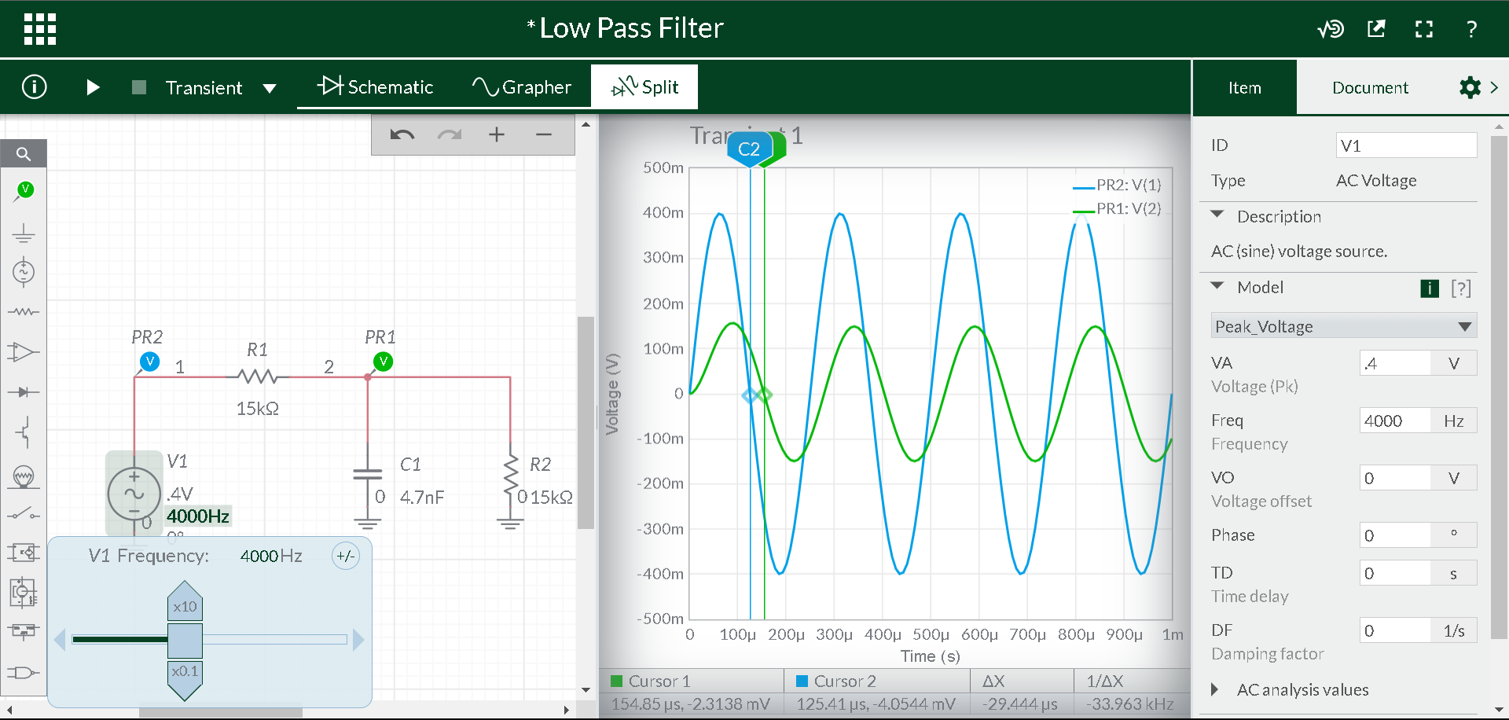

1. Low Pass 6kHz Transient Plot

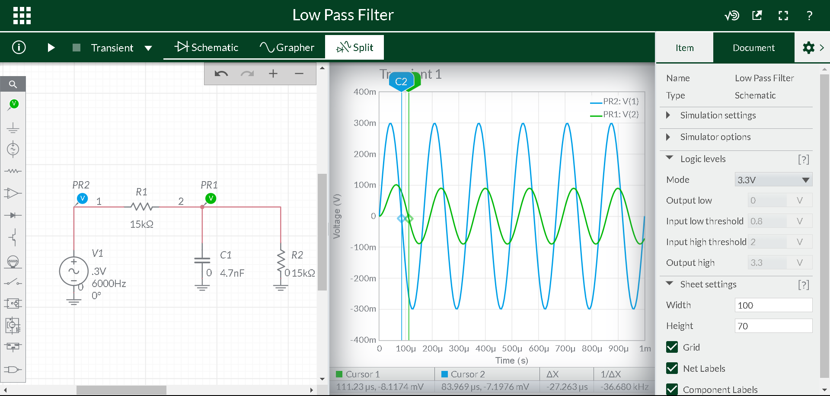

**High Pass Filter**

1. High Pass Filter Bode Plot

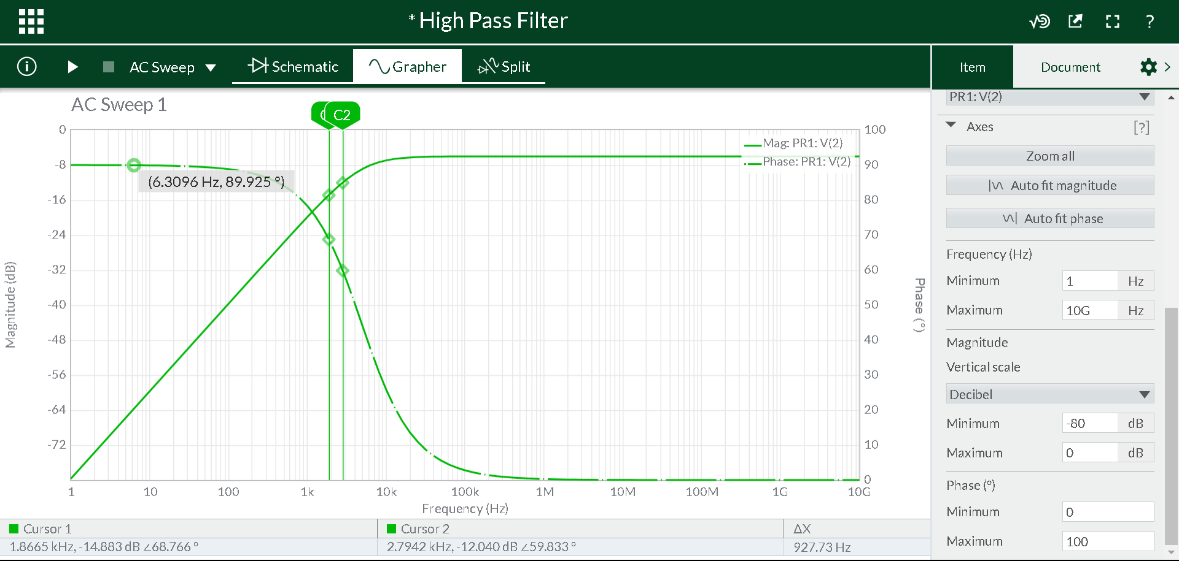

1. High Pass 4kHz Transient Plot

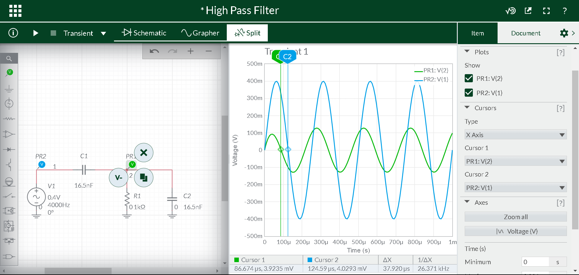

1. High Pass 6kHz Transient Plot

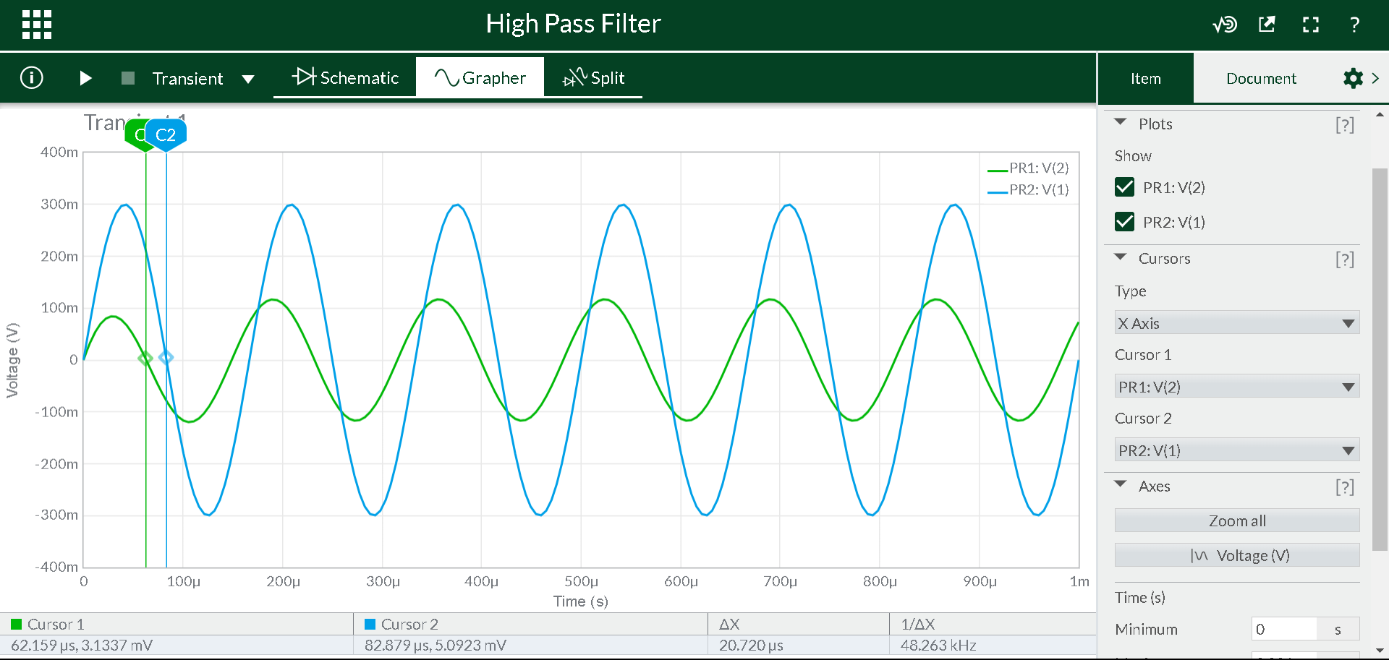

**Measurements:**

**Low Pass Filter**

1. Low Pass Filter Bode Plot

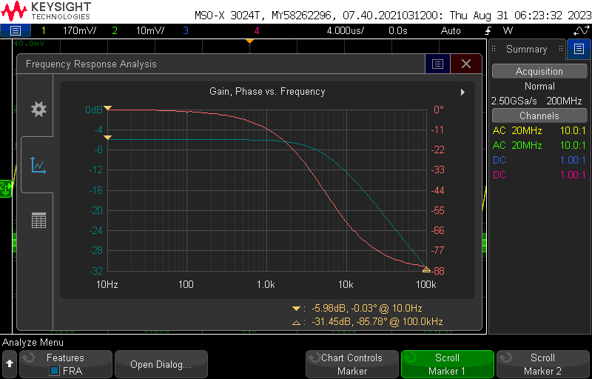

1. Low Pass 4kHz Transient Plot

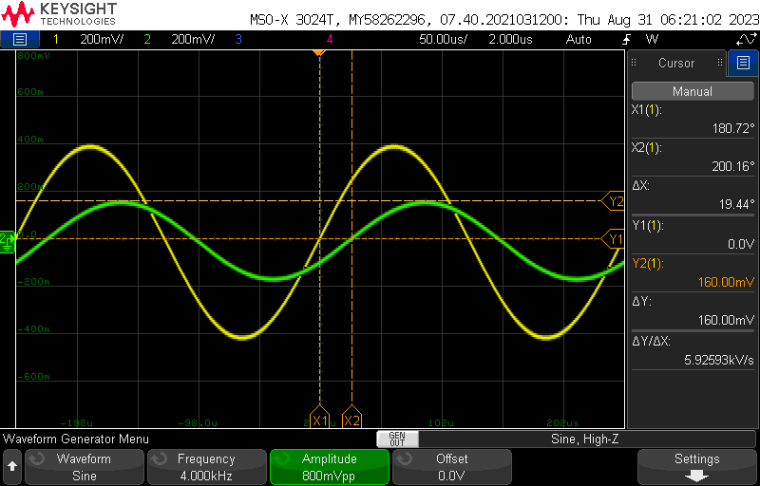

1. Low Pass 6kHz Transient Plot

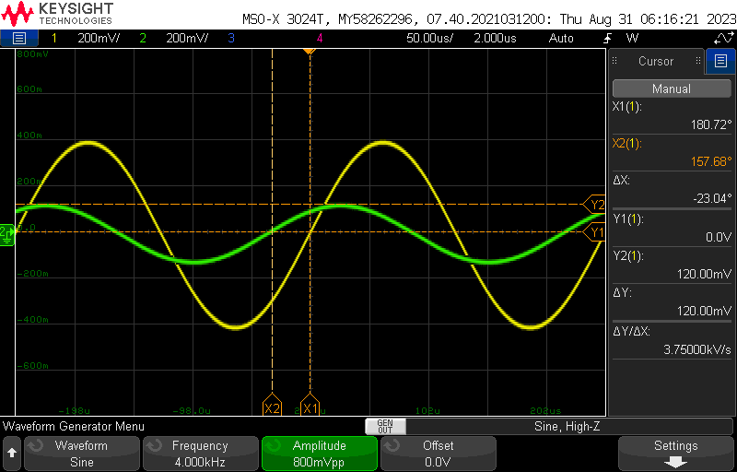

**High Pass Filter**

1. High Pass Filter Bode Plot

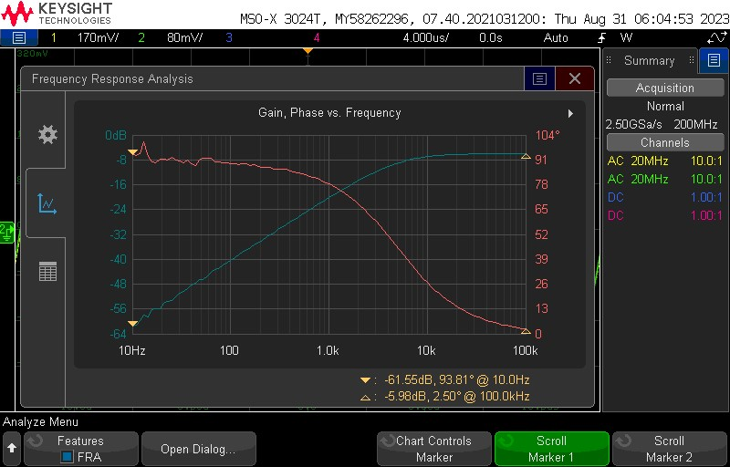

1. High Pass Filter 4kHz Transient Plot



1. High Pass Filter 6kHz Transient Plot

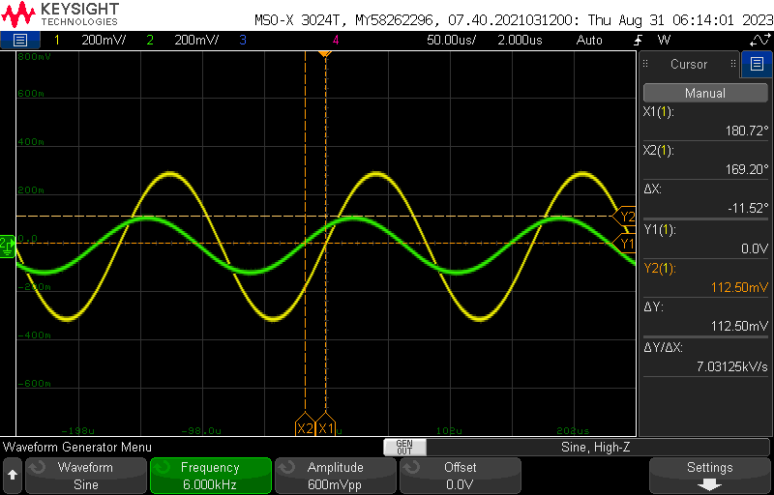

**Tables:**

1. Results from Calculations, Simulations, and Measurements

| **Calculated** | **Simulated** | **Measured** |
| --- | --- | --- |
| R1 = 13.545 kΩ | R1 = 15 kΩ | R1 = 15 kΩ |
| R2 = 13.545 kΩ | R2 = 15 kΩ | R2 = 15 kΩ |
| R3 = 1 kΩ | R3 = 1 kΩ | R3 = 1 kΩ |
| C1 = 4.7 nF | C1 = 4.7 nF | C1 = 4.7 nF |
| C2 = 4.7 nF | C2 = 4.7 nF | C2 = 4.7 nF |
| C3 = 16.5 nF | C3 = 16.5 nF | C3 = 16 nF |
| Low Pass 4kHz Vout = 0.156 V | Low Pass 4kHz Vout =  0.147 V | Low Pass 4kHz Vout =  0.160 V |
| Low Pass 4kHz Phase = -38.659 degrees | Low Pass 4kHz Phase = -42.393 degrees | Low Pass 4kHz Phase = -19.44 degrees |
| Low Pass 6kHz Vout = 0.096 V | Low Pass 6kHz Vout =  0.092 V | Low Pass 6kHz Vout =  0.100 V |
| Low Pass 6kHz Phase = -50.314 degrees | Low Pass 6kHz Phase = -58.888 degrees | Low Pass 6kHz Phase = 18.00 degrees |
| High Pass 4kHz Vout = 0.125 V | High Pass 4kHz Vout =  0.127 V | High Pass 4kHz Vout =  0.120 V |
| High Pass 4kHz Phase = 50.314 degrees | High Pass 4kHz Phase = 54.576 degrees | High Pass 4kHz Phase = 23.06 degrees |
| High Pass 6kHz Vout = 0.111 V | High Pass 6kHz Vout =  0.115 V | High Pass 6kHz Vout =  0.113 V |
| High Pass 6kHz Phase = 40.547 degrees | High Pass 6kHz Phase = 44.755 degrees | High Pass 6kHz Phase = 11.52 degrees |

**Conclusion:**

The main difference in the measured values from the simulated and calculated values is the phase difference. This great difference can be attributed to the fact that when measuring the phase difference the wrong x-axis was used. Due to a lack of experience with the Keysight oscilloscope, the time difference was not measured. This is needed to calculate the phase difference which was used in both calculation and simulation using this approach. Another difference of note is the use of 15kOhms instead of 13.545 kOhms resistors for the low pass filters and a 16 nF capacitor instead of a 16.5 nF capacitor. These changes were due to the parts provided. These design changes; however, behaved as expected which can be shown in the output voltage of the four circuits.